Bonding
A bond is force which holds particles together in molecules.
There a number of different types of bond. We call these bonding types:
-Ionic bonding
-Metallic bonding
-Covalent bonding
Ionic bonding
Here charged particles are held together due to their difference in charge.
Positive ions are attracted to negative ions.
Ionic boning=where ions are bonded together due to difference in charge.
Table salt is sodium chloride
Na⁺ bonds to Cl⁻
This gives the compound molecule
NaCl
Properties of ionic compounds

- Ionic compounds form crystals. We call this structure a crystal lattice
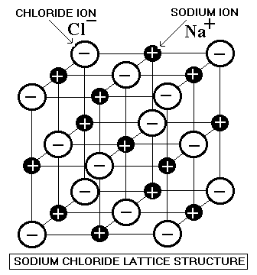
2. Ionic compounds have high melting points and high boiling points.
3. Ionic compounds are hard and brittle.
4. Ionic compounds conduct electricity when they are dissolved in water.

